**Artificial Intelligence-515**

Semester 6th

Name: _______ TAHRIM BILAL___________________________________

Roll Number: _____B21110006153_______________________________

Computer Science Department University Of Karachi

***Course Name (Course Code)*** ____515__________ ***Semester*** ___5th_____ ***Batch*** ___2022___

***Name of Student:***______TAHRIM BILAL______________***Roll No.***____B21110006153______

|  |  |  |  |  |  |
| --- | --- | --- | --- | --- | --- |
| **Lab** |  | **Description & Score** | |  |  |
| **1.** |  |  | |  |  |
| *Software Handling*  *( )/2* | *Programming/*  *Simulations*  *( )/5* | *Results*  *( )/2* | *Lab Report*  *( )/1* | *Score*  *( )/10* |
| **2.** |  |  | |  |  |
| *Software Handling*  *( )/2* | *Programming/*  *Simulations*  *( )/5* | *Results*  *( )/2* | *Lab Report*  *( )/1* | *Score*  *( )/10* |
| **3.** |  |  | |  |  |
| *Software Handling*  *( )/2* | *Programming/*  *Simulations*  *( )/5* | *Results*  *( )/2* | *Lab Report*  *( )/1* | *Score*  *( )/10* |
| **4.** |  |  | |  |  |
| *Software Handling*  *( )/2* | *Programming/*  *Simulations*  *( )/5* | *Results*  *( )/2* | *Lab Report*  *( )/1* | *Score*  *( )/10* |
| **5.** |  |  | |  |  |
| *Software Handling*  *( )/2* | *Programming/*  *Simulations*  *( )/5* | *Results*  *( )/2* | *Lab Report*  *( )/1* | *Score*  *( )/10* |
| **6.** |  |  | |  |  |
| *Software Handling*  *( )/2* | *Programming/*  *Simulations*  *( )/5* | *Results*  *( )/2* | *Lab Report*  *( )/1* | *Score*  *( )/10* |
| **7.** |  |  | |  |  |
| *Software Handling*  *( )/2* | *Programming/*  *Simulations*  *( )/5* | *Results*  *( )/2* | *Lab Report*  *( )/1* | *Score*  *( )/10* |
| **8.** |  |  | |  |  |
| *Software Handling*  *( )/2* | *Programming/*  *Simulations*  *( )/5* | *Results*  *( )/2* | *Lab Report*  *( )/1* | *Score*  *( )/10* |
| **9.** |  |  | |  |  |
| *Software Handling*  *( )/2* | *Programming/*  *Simulations*  *( )/5* | *Results*  *( )/2* | *Lab Report*  *( )/1* | *Score*  *( )/10* |
| **10.** |  |  | |  |  |
| *Software Handling*  *( )/2* | *Programming/*  *Simulations*  *( )/5* | *Results*  *( )/2* | *Lab Report*  *( )/1* | *Score*  *( )/10* |
| **11.** |  |  | |  |  |
| *Software Handling*  *( )/2* | *Programming/*  *Simulations*  *( )/5* | *Results*  *( )/2* | *Lab Report*  *( )/1* | *Score*  *( )/10* |
| **12.** |  |  | |  |  |
| *Software Handling*  *( )/2* | *Programming/ Simulations* | *Results*  *( )/2* | *Lab Report*  *( )/1* | *Score*  *( )/10* |
|  |  | *( )/5* |  |  |  |
| **13.** |  | | | |  |
| *Software Handling*  *( )/2* | *Programming/*  *Simulations*  *( )/5* | *Results*  *( )/2* | *Lab Report*  *( )/1* | *Score*  *( )/10* |
| **14.** |  | | | |  |
| *Software Handling*  *( )/2* | *Programming/*  *Simulations*  *( )/5* | *Results*  *( )/2* | *Lab Report*  *( )/1* | *Score*  *( )/10* |
| **TOTAL SCORE = 140 OBTAINED SCORE** | | | | |  |

***Overall Score: ___________ out of 50 Examined by****: _________________*  ***Overall Formula= (Obtained Score / Total Score)* x *50******(Name and Signature of Concerned)***

Artificial Intelligence-LAB (3+1)

***Instructor:*  Dr. Humera** Office Hours: ()

***Prerequisite:* Data Structures and Algorithms**

***Objectives:***

This Lab aims to Develop and Understand Artificial Intelligence by using Python.

***Contents:***

Artificial Intelligence has emerged as one of the most significant and promising areas of computing. This course focuses on the foundations of AI and its basic techniques like Symbolic manipulations, Pattern Matching, Knowledge Representation, Decision Making and appreciating the differences between Knowledge, Data and Code. AI programming language Lisp has been proposed for the practical work of this course.

**Learning Outcomes:**

**Mapping of CLOs and PLOs**

**Sr. No Course Learning Outcomes PLOs Blooms Taxonomy**

Understand the fundamental constructs of Python

**CLO_1** PLO_1 C2 (Understand) Programming language.

Understand key concepts in the field of artificial

**CLO_2** PLO_5 C2 (Understand)

intelligence

Implement artificial intelligence techniques and case

**CLO_3** PLO_3 C3 (Apply)

studies

***Recommended Book:***

**1.** Stuart Russell and Peter Norvig, Artificial Intelligence. A Modern Approach, 3rd edition, Prentice Hall, Inc., 2010. ***Reference Books:***

1. **Artificial Intelligence Engines: A Tutorial Introduction to the Mathematics of Deep Learning By – James V Stone**
2. Hart, P.E., Stork, D.G. and Duda, R.O., 2001. Pattern classification. John Willey & Sons.
3. Luger, G.F. and Stubblefield, W.A., 2009. AI algorithms, data structures, and idioms in Prolog, Lisp, and Java. Pearson Addison-Wesley.

***Administrative Instructions:***

▪ According to institute policy, 75% attendance is *mandatory* to appear in the final examination but 100% will be expected. Approved leaves will not be considered towards attendance.

▪ Every student should bring calculator, book and manual in each lab.

▪ Every student is expected to be in lab before schedule starting time.

▪ In any case there will be no rescheduling and makeup of labs.

**Lab-01**

**Introduction to Python**

**Objectives:**

The purpose of this lab is to get you familiar with Python and its IDE.

**Lab #01 task:**

### Exercise: Dir and Help

Learn about the methods Python provides for strings. To see what methods Python provides for a datatype, use the dir and help commands:

>>> s = 'abc'

**>>> dir(s)**

['__add__', '__class__', '__contains__', '__delattr__', '__doc__', '__eq__',

'__ge__', '__getattribute__', '__getitem__', '__getnewargs__',

'__getslice__', '__gt__', '__hash__', '__init__','__le__', '__len__',

'__lt__', '__mod__', '__mul__', '__ne__', '__new__', '__reduce__',

'__reduce_ex__','__repr__', '__rmod__', '__rmul__', '__setattr__', '__str__', 'capitalize', 'center', 'count', 'decode', 'encode', 'endswith',

'expandtabs', 'find', 'index', 'isalnum', 'isalpha', 'isdigit', 'islower',

'isspace', 'istitle', 'isupper', 'join', 'ljust', 'lower', 'lstrip',

'replace', 'rfind','rindex', 'rjust', 'rsplit', 'rstrip', 'split',

'splitlines', 'startswith', 'strip', 'swapcase', 'title', 'translate', 'upper', 'zfill']

**>>> help(s.find)**

Help on built-in function find:

find(...) method of builtins.str instance

S.find(sub[, start[, end]]) -> int

Return the lowest index in S where substring sub is found, such that sub is contained within S[start:end]. Optional arguments start and end are interpreted as in slice notation.

Return -1 on failure.

>> s.find('b')

1. Try out some of the string functions listed in dir (ignore those with underscores '_' around the method name).

CODE 1:



OUTPUT 1:



CODE 2:



OUTPUT 2:



CODE 3:



OUTPUT 3:



### Exercise Python input /output Basic operations

(i)Write a Python program to swap 4 variables values (input four values.

Sample input: Before swapping a=2,b=56,c=78,d=9 After Swapping a=,9,b=78,c=56,d=2

CODE:

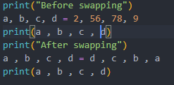

OUTPUT:

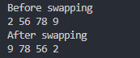

(ii) Write a Python program to convert temperatures to and from celsius, Fahrenheit.

Formula: c/5 = f-32/9 Expected Output :

Enter temp in Celsius: 60°C

Temperature in Fahrenheit is: 140

CODE:

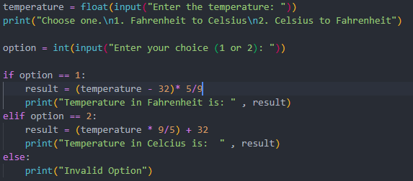

OUTPUT:

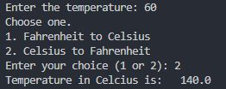

### Exercise: Lists

(i)Play with some of the list functions. You can find the methods you can call on an object via the dir and get information about them via the help command:

>>> dir(list)

['__add__', '__class__', '__contains__', '__delattr__', '__delitem__', '__delslice__', '__doc__', '__eq__', '__ge__', '__getattribute__',

'__getitem__', '__getslice__', '__gt__', '__hash__', '__iadd__', '__imul__',

'__init__', '__iter__', '__le__', '__len__', '__lt__', '__mul__', '__ne__',

'__new__', '__reduce__', '__reduce_ex__', '__repr__', '__reversed__',

'__rmul__', '__setattr__', '__setitem__', '__setslice__', '__str__', 'append', 'count', 'extend', 'index', 'insert', 'pop', 'remove', 'reverse', 'sort']

>>> help(list.reverse)

Help on built-in function reverse:

reverse(...)

L.reverse() -- reverse *IN PLACE*

>>> lst = ['a','b','c']

>>> lst.reverse()

>>> ['c','b','a']

Note: Ignore functions with underscores "_" around the names; these are private helper methods. Press 'q' to back out of a help screen

CODE 1:

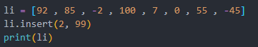

OUTPUT 1:



CODE 2:

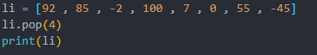

OUTPUT 2:



CODE 3:

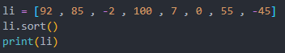

OUTPUT 3:



(ii)Write a Python program to count the number of strings where the string length is 2 or more and the first and last character are same from a given list of strings.

Sample List : ['abc', 'xyz', 'aba', '1221']

Expected Result : 2.

CODE:  
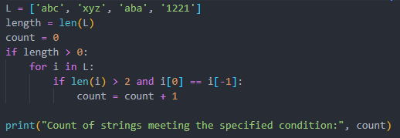

OUTPUT:



**Exercise: Dictionaries**

(i)Use dir and help to learn about the functions you can call on dictionaries and implement it.

CODE:  
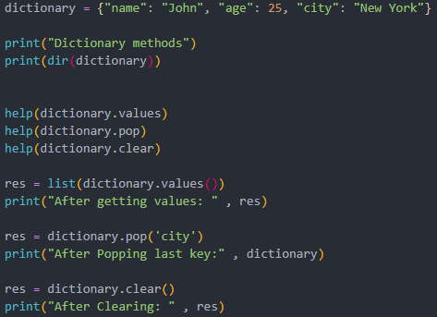

OUTPUT:

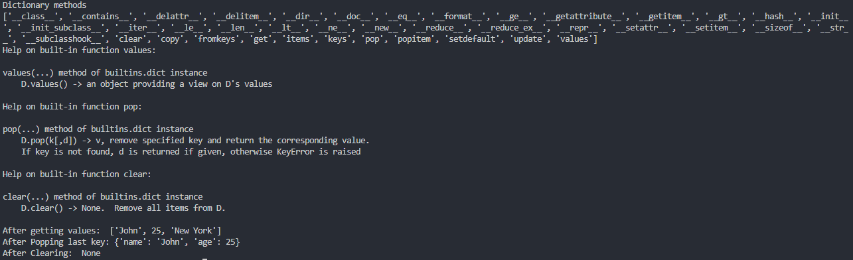

(ii)Write a Python script to concatenate following dictionaries to create a new one.

Sample Dictionary : dic1={1:10, 2:20} dic2={3:30, 4:40} dic3={5:50,6:60}

Expected Result : {1: 10, 2: 20, 3: 30, 4: 40, 5: 50, 6: 60}

CODE:  
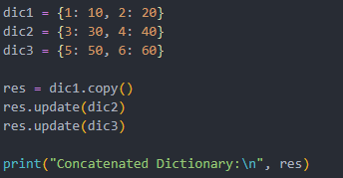

OUTPUT:



### Exercise: List Comprehensions

(i)Write a list comprehension which, from a list, generates a lowercased version of each string that has length greater than five.

CODE:

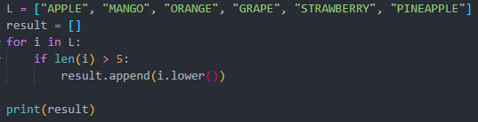

OUTPUT:



(ii)Write a Python program to print a specified list after removing the 0th, 4th and 5th elements

Sample List : ['Red', 'Green', 'White', 'Black', 'Pink', 'Yellow',’Teapink’]

Expected Output : ['Green', 'White', 'Black']

CODE:

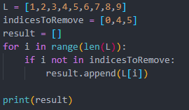

OUTPUT:



### Exercise : Operators:

Play with some Operators in Python(assignment ,bitwise ,logical, arithmetic, identity, membership)

(i) What will be the output of the given program

|  |  |
| --- | --- |
| **Identity Operators in Python** x = 6 if (type(x) is int): print ("true") else:  print ("false") | **Output:** |
| x = 7.2 if (type(x) x = 7.2 if (type(x) is not int): print ("true") else:  print ("false") | **Output:** |
| **Membership operator:**  list1=[1,2,3,4,5] | **Output:** |
| list2=[6,7,8,9] for item in list1: if item in list2:  print("overlapping") else:  print("not overlapping") |  |
| **Floor division and Exponent and Assign** a//=3 a**=5 print(“floor divide=”,a) print(“exponent=”,a) | **Output:** |
| Bitwise Operaotors: a = 60 /* 60 = 0011 1100 */   1. = 13 /* 13 = 0000 1101 */   int c = 0     1. = a & b /* 12 = 0000 1100 */ print("Line 1", c )     c = a | b /* 61 = 0011 1101 */ print("Line 2 ", c )    c = a ^ b /* 49 = 0011 0001 */ print("Line 3 ", c )    c = ~a /*-61 = 1100 0011 */ print("Line 4", c )    c = a << 2 /* 240 = 1111 0000 */ printf("Line 5 ", c );    c = a >> 2 /* 15 = 0000 1111 */  printf("Line 6 -", c ); | **Output** |

Exercise

Create a Python Program that perform following tasks for any problem of your choice:

Task 1: Introduction

Task 2: Terminal

Task 3: Python Interpreter

Task 4: Variables

Task 5: Text Editor

Task 6: Functions

Task 7: [Lists](https://elearn.daffodilvarsity.edu.bd/mod/resource/view.php?id=80435) and Tuples

Task 8: Conditional Statements

Task 9: The For Loop

Task 10: User Input and the While Loop

CODE:

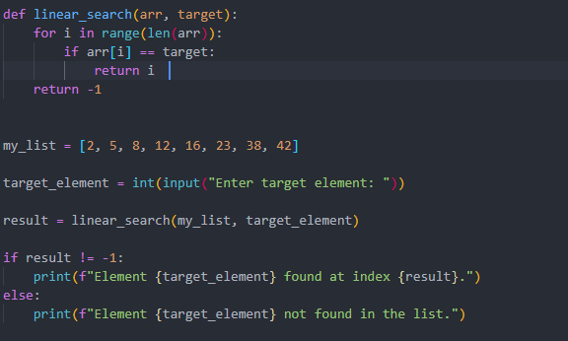

OUTPUT:



**Resources:**

1. [https://github.com/rajuiit/Machine-Learning-Summer-](https://github.com/rajuiit/Machine-Learning-Summer-2020/blob/master/week_2_basicpython.ipynb)

[2020/blob/master/week_2_basicpython.ipynb](https://github.com/rajuiit/Machine-Learning-Summer-2020/blob/master/week_2_basicpython.ipynb)

1. [https://github.com/rajuiit/Machine-Learning-Summer](https://github.com/rajuiit/Machine-Learning-Summer-2020/blob/master/week_2_use_of_build_in_function.ipynb)

[2020/blob/master/week_2_use_of_build_in_function.ipynb](https://github.com/rajuiit/Machine-Learning-Summer-2020/blob/master/week_2_use_of_build_in_function.ipynb)